**Your Task:** Your task is to apply both the functions using any dataset you want and send me the code and also a report and what you have analyzed in the correlation function.

To

Rishabh Goyal,

From

Pampana Jai Kiran.

Sir, I have successfully completed the task 5.

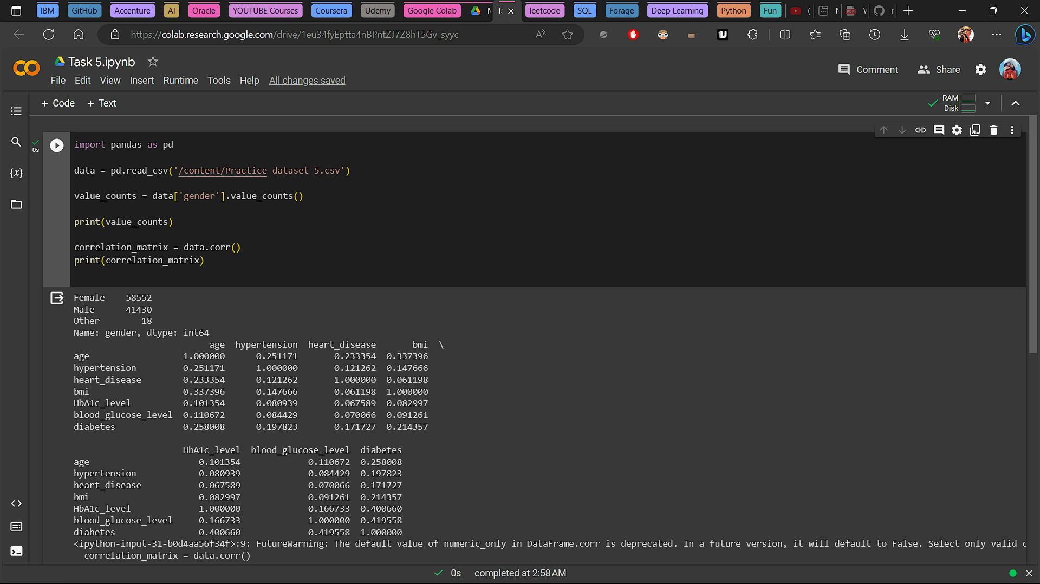

**Data Analysis Report**

Gender Distribution Analysis

**Summary**

In this analysis, we examined the gender distribution within the dataset.

**Gender Distribution:**

Female: 58,552

Male: 41,430

Other: 18

**Observations**

The majority of individuals in the dataset identify as female, with a count of 58,552.

The dataset also includes a significant number of male individuals, with a count of 41,430.

A very small number of individuals are classified as 'Other,' with a count of 18.

**Correlation Analysis:**

**Summary**

In this analysis, we calculated the Pearson correlation matrix for the dataset, which includes variables such as 'age,' 'hypertension,' 'heart_disease,' 'bmi' (body mass index), 'HbA1c_level,' 'blood_glucose_level,' and 'diabetes.'

1. Age and Hypertension: There is a positive correlation of approximately 0.25 between age and hypertension, indicating that as age increases, the likelihood of hypertension also increases to some extent.

2. Age and Heart Disease: Age is positively correlated with heart disease (correlation coefficient ≈ 0.23), suggesting that older individuals may be more likely to have heart disease.

3. Age and BMI: There is a positive correlation of approximately 0.34 between age and BMI, suggesting that as individuals age, their BMI tends to increase.

4. HbA1c Level and Diabetes: HbA1c level and diabetes show a strong positive correlation (correlation coefficient ≈ 0.40), indicating that individuals with higher HbA1c levels are more likely to have diabetes.

5. Blood Glucose Level and Diabetes: Blood glucose level and diabetes also exhibit a strong positive correlation (correlation coefficient ≈ 0.42), suggesting that higher blood glucose levels are associated with a higher likelihood of diabetes.